Nối kết đến CSDL SQL Server trong Lab

1. Start SQL service

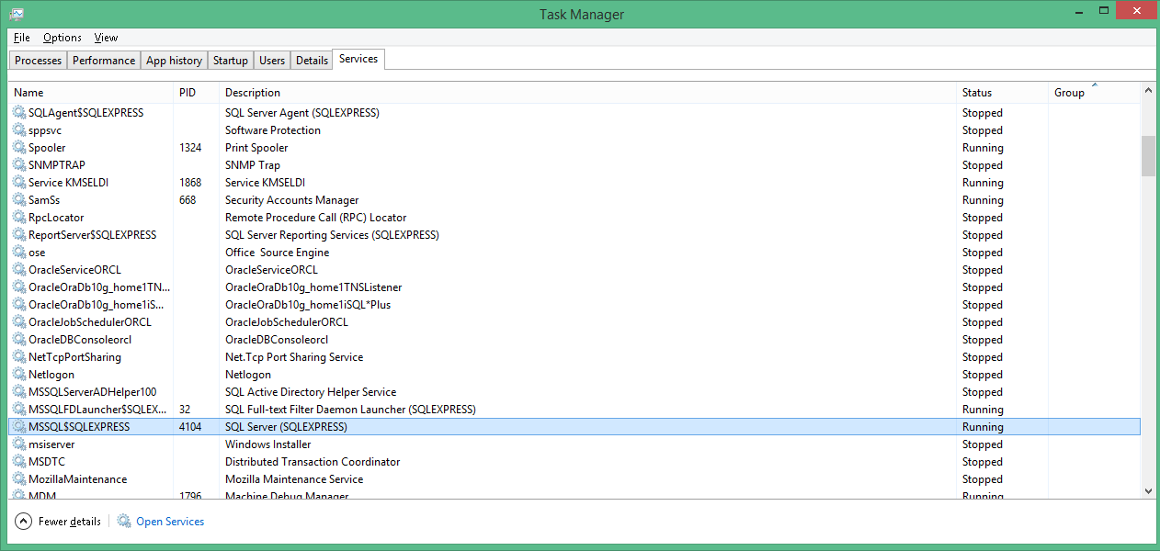

1. Login

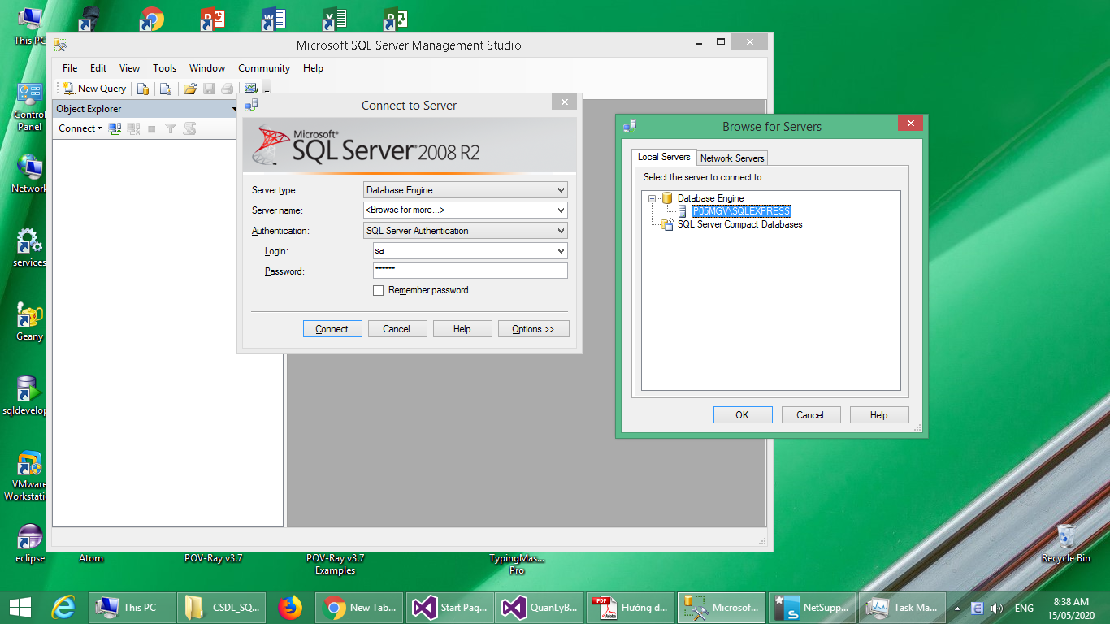

(Authentification: SQL Server Authentification; login: sa; Password: sa2008)

Scenario: what to test?

Test case: How to test?